LAB 3: UNINFORMED SEARCH
BFS, DFS, DLS, IDDFS AND UCS
Name: Noor Shehzadi
Roll No: 356
Section: BSAI-3B

1. Objective
The objective of this lab is to implement and compare uninformed search algorithms: Breadth-First Search (BFS), Depth-First Search (DFS), Depth-Limited Search (DLS), Iterative Deepening DFS (IDDFS), and Uniform Cost Search (UCS). The search starts from A and tries to reach goal G.

2. State-Space Graph for BFS, DFS, DLS and IDDFS
Start node: A
Goal node: G
Successor order: left to right
Depth of the root node A: 0
Graph:
A
/ \
B C
/ \ \
D E F
\
G
Adjacency list:
A: [B, C]
B: [D, E]
C: [F]
D: []
E: [G]
F: []
G: []

3. BFS Manual Trace
BFS uses a queue. Queue follows FIFO (First In, First Out). The node at the left/front is removed first.
Step 0: Processed node: No node processed. Queue: [A]
Step 1: Processed node: A. Queue: [B, C]
Step 2: Processed node: B. Queue: [C, D, E]
Step 3: Processed node: C. Queue: [D, E, F]
Step 4: Processed node: D. Queue: [E, F]
Step 5: Processed node: E. Queue: [F, G]
Step 6: Processed node: F. Queue: [G]
Step 7: Processed node: G (goal). Queue: []
BFS visit order: A, B, C, D, E, F, G
BFS final path: A → B → E → G
Number of edges: 3
Path length calculation: A to B = 1 edge, B to E = 1 edge, E to G = 1 edge. Total = 1 + 1 + 1 = 3 edges.
The BFS program output is included below.
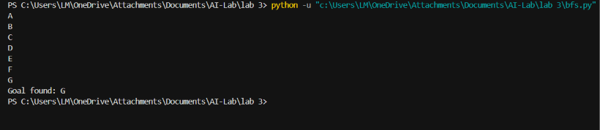

4. DFS Manual Trace
DFS uses a stack. Stack follows LIFO (Last In, First Out). The last item added to the stack is removed first. The code inserts neighbours in reversed order so that the first neighbour in the graph is visited first. The rightmost item shown below is the top of the stack.
Step 0: Processed node: No node processed. Stack: [A]
Step 1: Processed node: A. Stack: [C, B]
Step 2: Processed node: B. Stack: [C, E, D]
Step 3: Processed node: D. Stack: [C, E]
Step 4: Processed node: E. Stack: [C, G]
Step 5: Processed node: G (goal). Stack: [C]
DFS visit order: A, B, D, E, G
DFS final path: A → B → E → G
Number of edges: 3
Path length calculation: A to B = 1 edge, B to E = 1 edge, E to G = 1 edge. Total = 1 + 1 + 1 = 3 edges.
The DFS program output is included below.
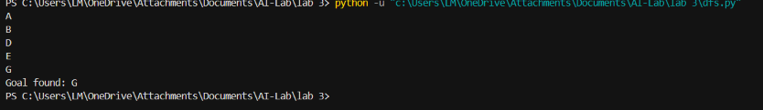

5. DLS Results
DLS is DFS with a maximum depth limit. The root A is at depth 0. The program was run with limits 1, 2, 3 and 4.
Limit 1: Status = CUTOFF; Path = None
Limit 2: Status = CUTOFF; Path = None
Limit 3: Status = FOUND; Path = A → B → E → G
Limit 4: Status = FOUND; Path = A → B → E → G
A CUTOFF means that the search reached its depth limit while a deeper continuation remained. It does not prove that the goal is unreachable. The goal is found when the depth limit reaches 3.
The actual DLS terminal output is included below.
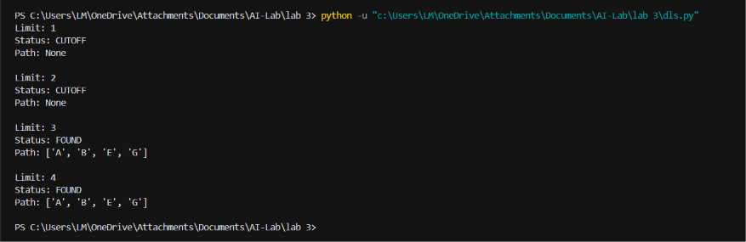

6. IDDFS Results
IDDFS repeats depth-limited search with increasing depth limits. It starts at depth 0 and uses a fresh path for each new limit.
Depth limit 0: Status = CUTOFF; Path = None
Depth limit 1: Status = CUTOFF; Path = None
Depth limit 2: Status = CUTOFF; Path = None
Depth limit 3: Status = FOUND; Path = A → B → E → G
Final IDDFS path: A → B → E → G
The actual IDDFS terminal output is included below.
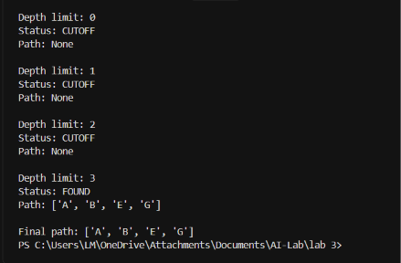

7. Weighted Graph for BFS and UCS Comparison
For the weighted experiment, the original vertices and corridors are retained and the alternative corridor C → G is added. All edge costs are nonnegative.
Weighted edges and costs:
A → B = 1
A → C = 6
B → D = 4
B → E = 1
C → F = 3
C → G = 6 (added alternative corridor)
E → G = 1
Weighted graph (arrows show direction; numbers show edge costs):
A --1--> B --1--> E --1--> G
\
6
\
C --6--> G
|
3
v
F
B --4--> D

8. BFS and UCS Path-Cost Calculation

BFS result on the weighted graph
BFS selects the route with the fewest number of edges.
Path: A → C → G
Cost calculation: A → C = 6; C → G = 6.
Total cost = 6 + 6 = 12.
Number of edges = 2.

UCS result
UCS expands the frontier node with the lowest accumulated path cost.
Processing order shown by the submitted UCS output: A (cost 0), B (cost 1), E (cost 2), G (cost 3).
Final path: A → B → E → G
Cost calculation: A → B = 1; B → E = 1; E → G = 1.
Total cost = 1 + 1 + 1 = 3.
Number of edges = 3.
The UCS terminal output is included below.
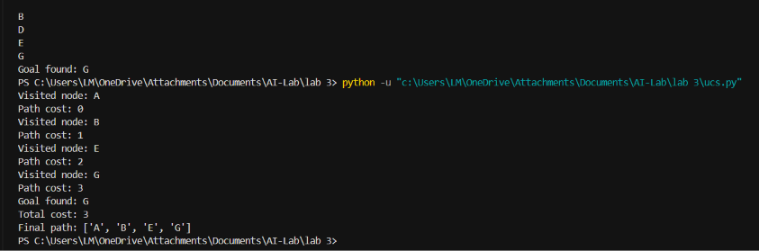

9. Comparison and Interpretation
BFS path: A → C → G. It has 2 edges and total cost 12.
UCS path: A → B → E → G. It has 3 edges and total cost 3.
BFS chooses the route with fewer edges when each step is treated equally. UCS considers the accumulated edge cost and chooses the lowest-cost route. Therefore, the BFS route has fewer edges, but it costs more. The UCS route has one extra edge, but its total cost is lower.

10. Edge Case / Failure Analysis
The DLS run with depth limit 2 is an example of a bounded-search cutoff. Its result is CUTOFF and no path is returned because the goal G is at depth 3. This result does not mean that G is unreachable; it only means that the selected limit is too small.
Observed behavior: Limit 2 returns CUTOFF. Limit 3 returns FOUND with path A → B → E → G.
Likely reason: The depth limit prevents the search from exploring the full path to G.
Improvement: Increase the depth limit or use IDDFS, which gradually increases the limit until the goal is found.
The manual also asks students to test start-equals-goal, an unreachable goal, and a graph containing a cycle. These additional cases are not shown in the supplied terminal screenshots and should be run separately if the instructor expects their individual outputs.

11. Algorithm Concepts
BFS: Uses a queue (FIFO) and explores nodes level by level.
DFS: Uses a stack (LIFO) and explores one branch deeply before backtracking.
DLS: Uses depth-first search with a fixed maximum depth.
IDDFS: Repeats DLS with increasing depth limits.
UCS: Uses a priority queue and expands the node with the lowest accumulated path cost.

12. Reflection
I learned how BFS, DFS, DLS, IDDFS and UCS explore a graph in different ways. I learned that BFS uses a queue, DFS uses a stack, and UCS uses a priority queue based on path cost.
These algorithms can be applied in AI systems such as route planning and robot navigation. A robot may need the shortest route or the route with the lowest travel cost.
The DLS result showed that a small depth limit can stop the search before reaching the goal. Increasing the limit through IDDFS helped find the goal.
In future, I would test more cases, including an unreachable goal and a graph with a cycle, and compare the actual outputs carefully.

13. Conclusion
The experiments show that search algorithms use different strategies. BFS and DFS find the same path in the original graph, but their visit orders differ. DLS and IDDFS demonstrate how depth limits affect search. In the weighted graph, BFS returns a route with fewer edges, while UCS finds the route with the lower total cost.

